Attachment B - Site Map
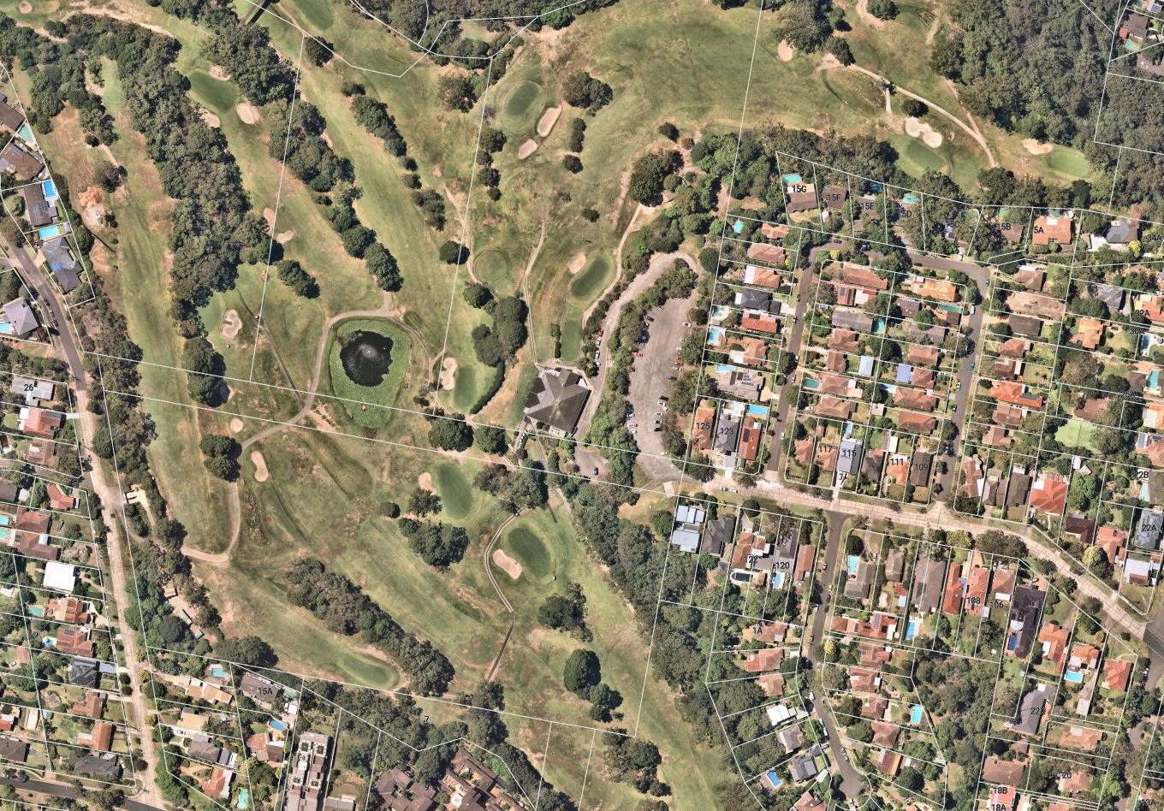
Site
Existing clubhouse
Chatswood Golf Course
Site
N
Beaconsfield Road
Cramer Crescent
Colwell Crescent
Colwell Crescent
Colwell Crescent
Lot 163 DP752067
Lot 1 DP651667
Lot 1 DP1124646
Lot 22 DP626634
Figure 1: Subject site (source: Near Map, overlay by DPIE)

